Linus Basics Commands

- Objective: Create a new Linux user named techie and grant administrator (sudo) privileges.
Purpose: To understand user management and privilege escalation in Linux.
Implementation: Ubuntu/Debian
$ sudo adduser Techie
$ sudo usermod -aG sudo Techie
Verify: $groups techie
Conclusion: A new user was successfully created and granted administrative privileges. 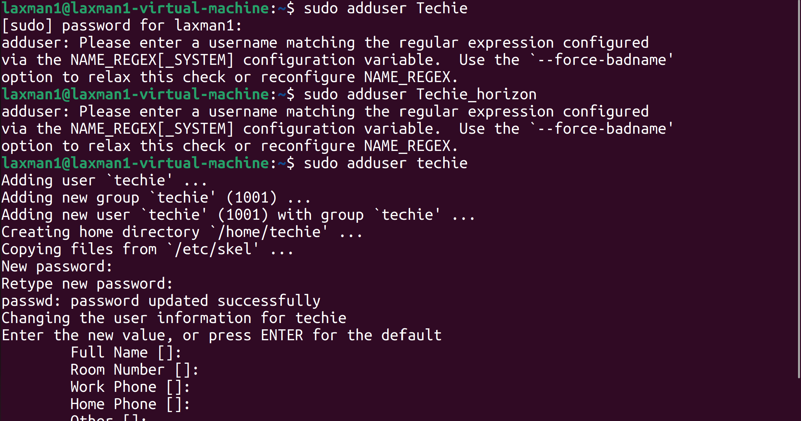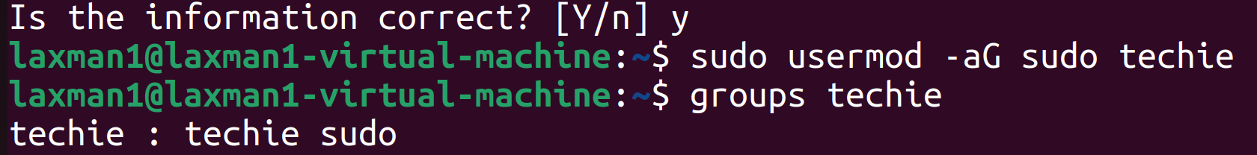

- Objective: Navigate to the current user's home directory. Purpose: To understand directory navigation. Implementation: $ cd ~ or $ cd
Verify: $pwd
Conclusion: Successfully navigated to the home directory. 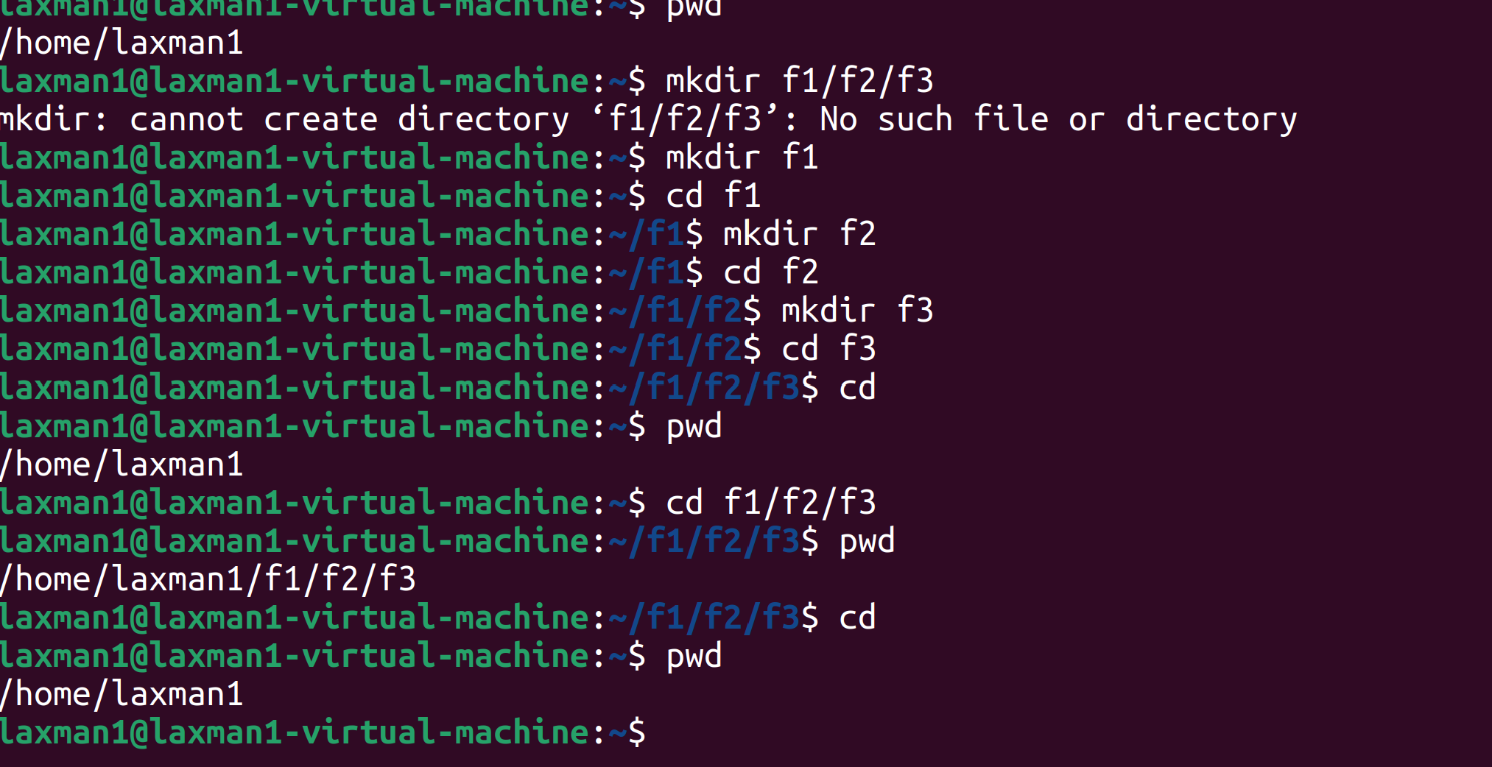

- Objective: Create a directory named plsrojects. Purpose: To learn directory creation. Implementation: $ mkdir projects
Verify: $ls -ltr
Conclusion: A new directory named projects was created successfully.
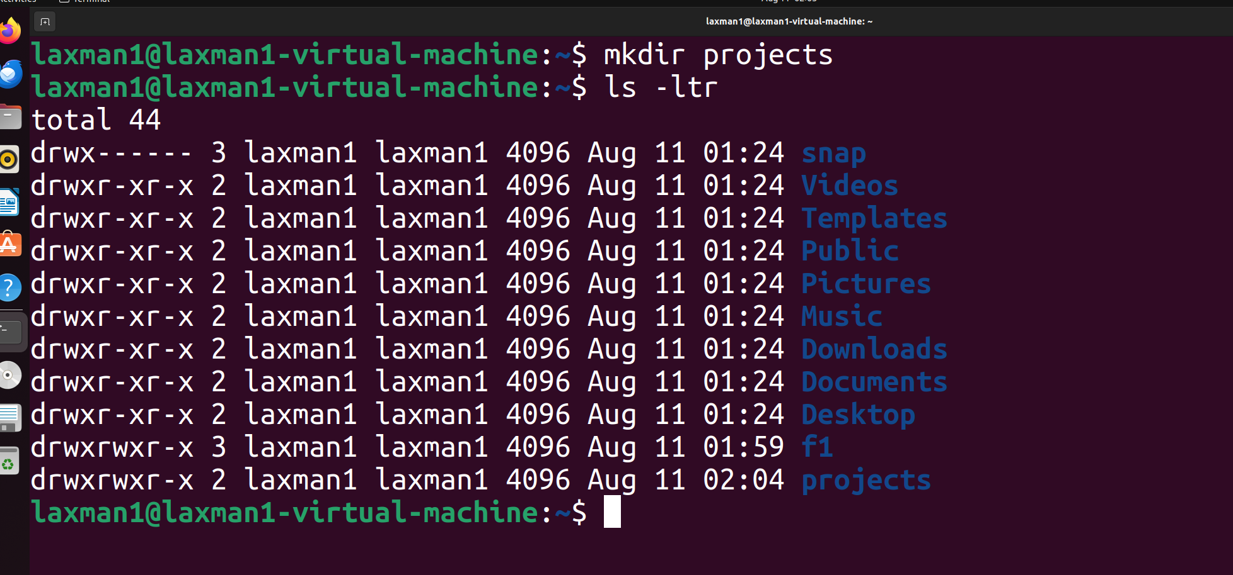
- Objective: Display files and directories. Purpose: To understand directory listing. Implementation: $ ls -ltr f1/f2/f3
Conclusion: The contents of the directory were displayed successfully

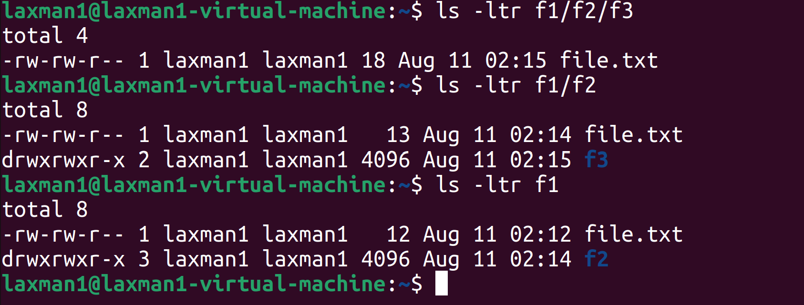

- Objective: Navigate to another directory. Purpose: To understand directory traversal. Implementation: $ cd d1/f1
Verify: $pwd
Conclusion: The current working directory was changed successfully.
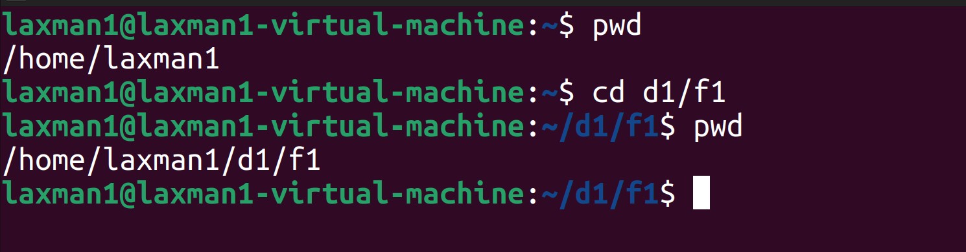

- Objective: Create an empty file named notes.txt. Purpose: To learn file creation. Implementation: touch notes.txt
Verify: ls *.txt -ltr
Conclusion: An empty file was successfully created. 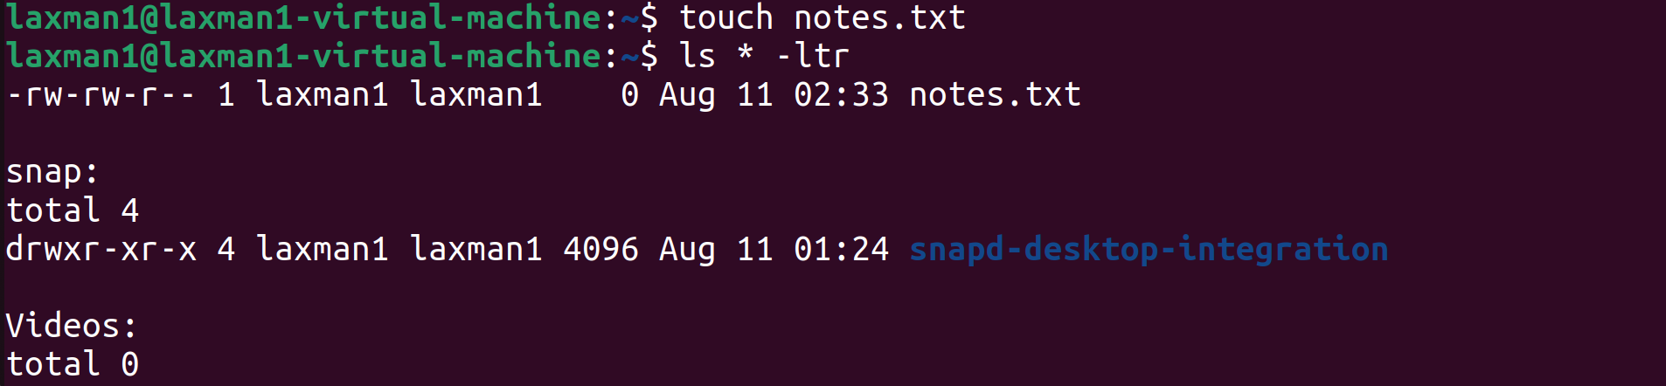

- Objective: Display the contents of a file. Purpose: To learn how to read files. Implementation: $cat newfile.txt
Conclusion: The file contents were displayed successfully.
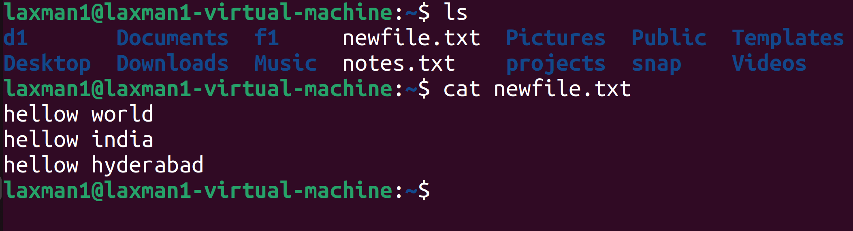
- Objective: Copy notes.txt to the home directory. Purpose: To understand file copying. Implementation: $cp notes.txt d1
Verify: $ls d1 -ltr
Conclusion: The file was copied successfully.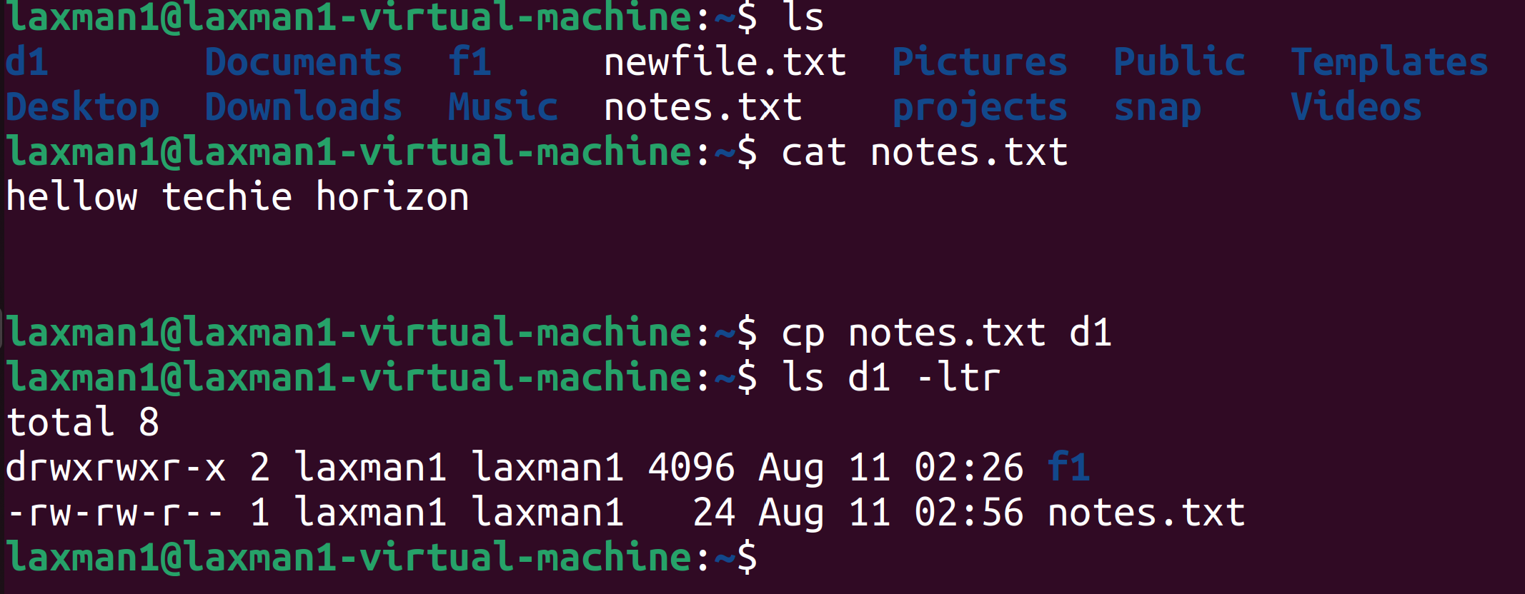

Objective: Move a file into another directory. Purpose: To understand file movement. Implementation: mv F1/F2/File.txt F1/F2/F3/ Verify: $ls F1/F2/F3/
Conclusion: The file was moved successfully.

- Objective: Rename a file.
Purpose: To understand file renaming. Implementation: $mv File.txt File_new.txt Verify: $ls *.txt -ltr
Conclusion: The file was renamed successfully.

- Objective: Delete a file.
Purpose: To learn file removal. Implementation: $rm File_new.txt Verify: $ls -ltr *.txt
Conclusion: The file was deleted successfully.

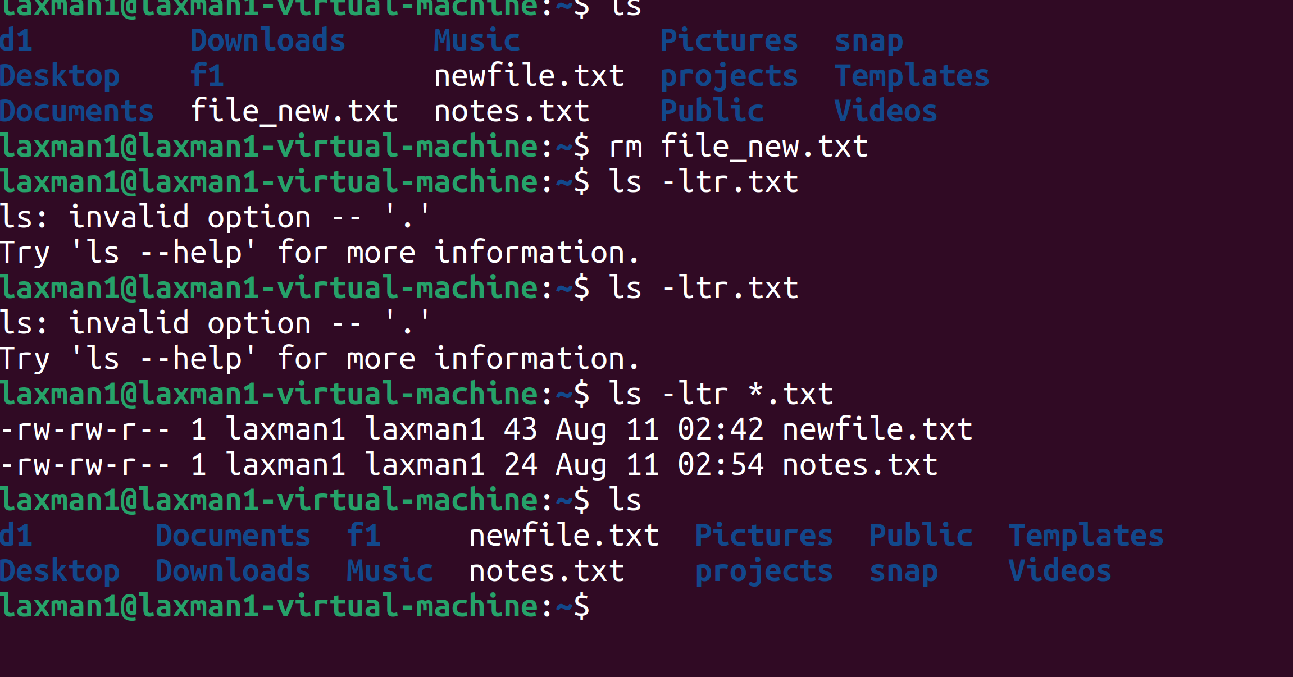
- Objective: Modify file permissions.
Purpose: To understand Linux file permissions.

Implementation:
Grant read & execute permission: $chmod 755 source.txt
Remove write permission to User and Grand read permission to all : $chmod 444 newfile.txt
Verify: $ls -l script.sh
Conclusion: Permissions were successfully granted or revoked.

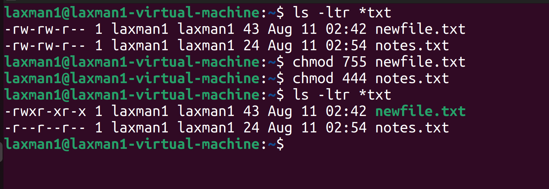
- Objective: Display the current system date and time. Purpose: To learn basic system information commands. Implementation: $date
Conclusion: The current system date and time were displayed successfully.

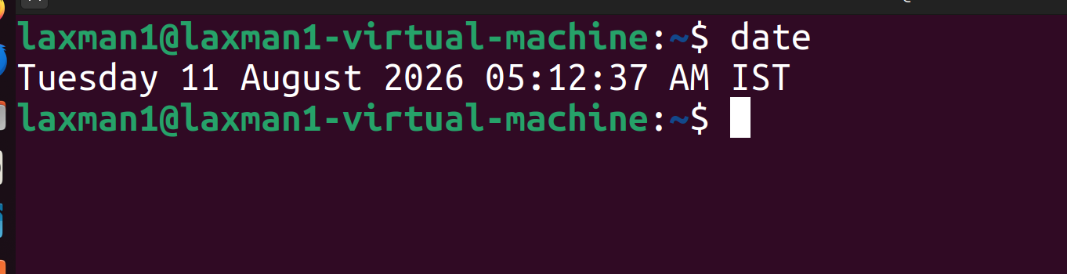

- Objective: View how long the system has been running. Purpose: To monitor system availability. Implementation: $uptime
Conclusion: The system uptime information was displayed successfully.

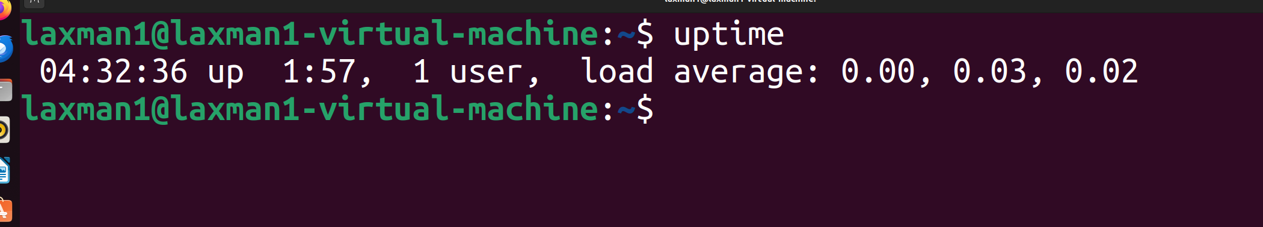

- Objective: Display active processes. Purpose: To understand process monitoring. Implementation: $ps -ef or $top
Conclusion: The currently running processes were displayed successfully. 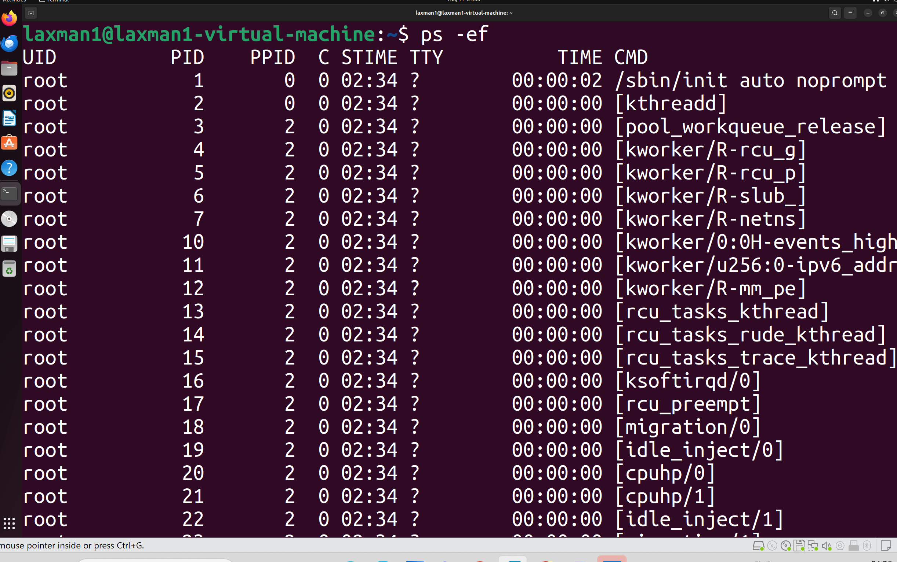

- Objective: Terminate a running process. Purpose: To understand process management. Implementation:
Find the process: $ps -ef Kill the process: $kill 5110 Force kill: $kill -9 <PID> Example: $kill -9 12345
Conclusion: The specified process was terminated successfully.
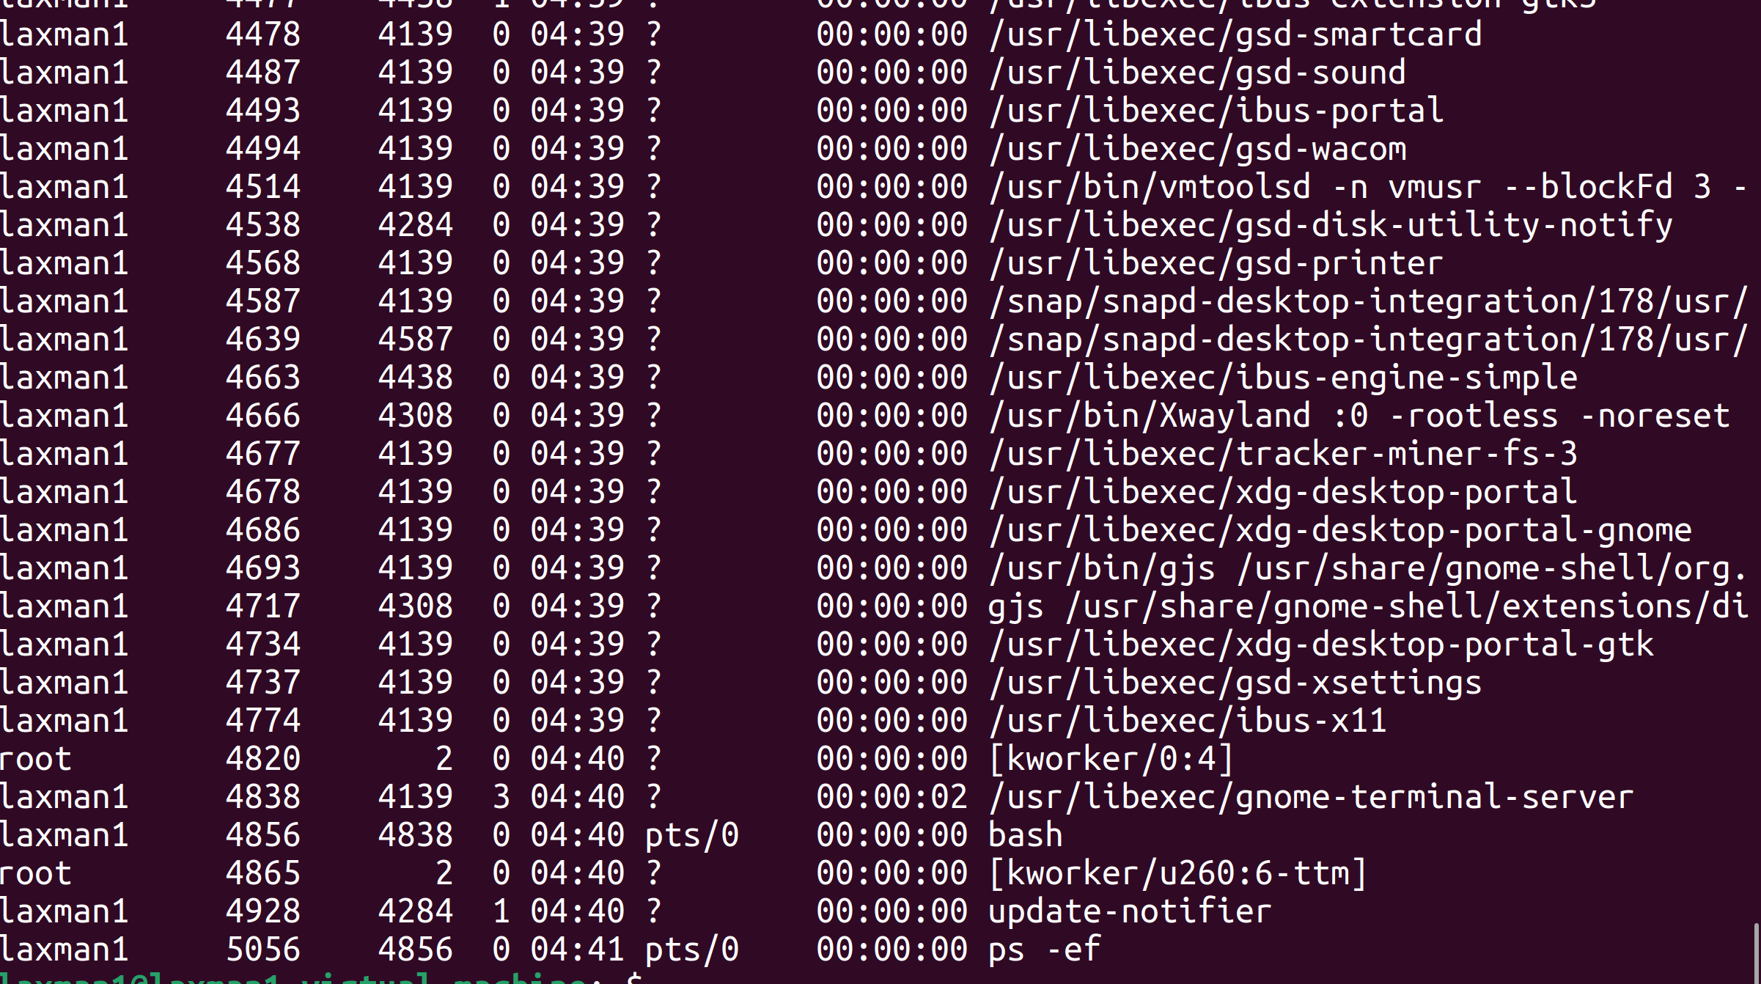
- Objective: Install a software package. Purpose: To learn package installation. Implementation:
Ubuntu/Debian: $sudo apt update
$ sudo apt install tree
RHEL/CentOS: $sudo yum install tree
$Verify: tree --version
Conclusion: The package was installed successfully.

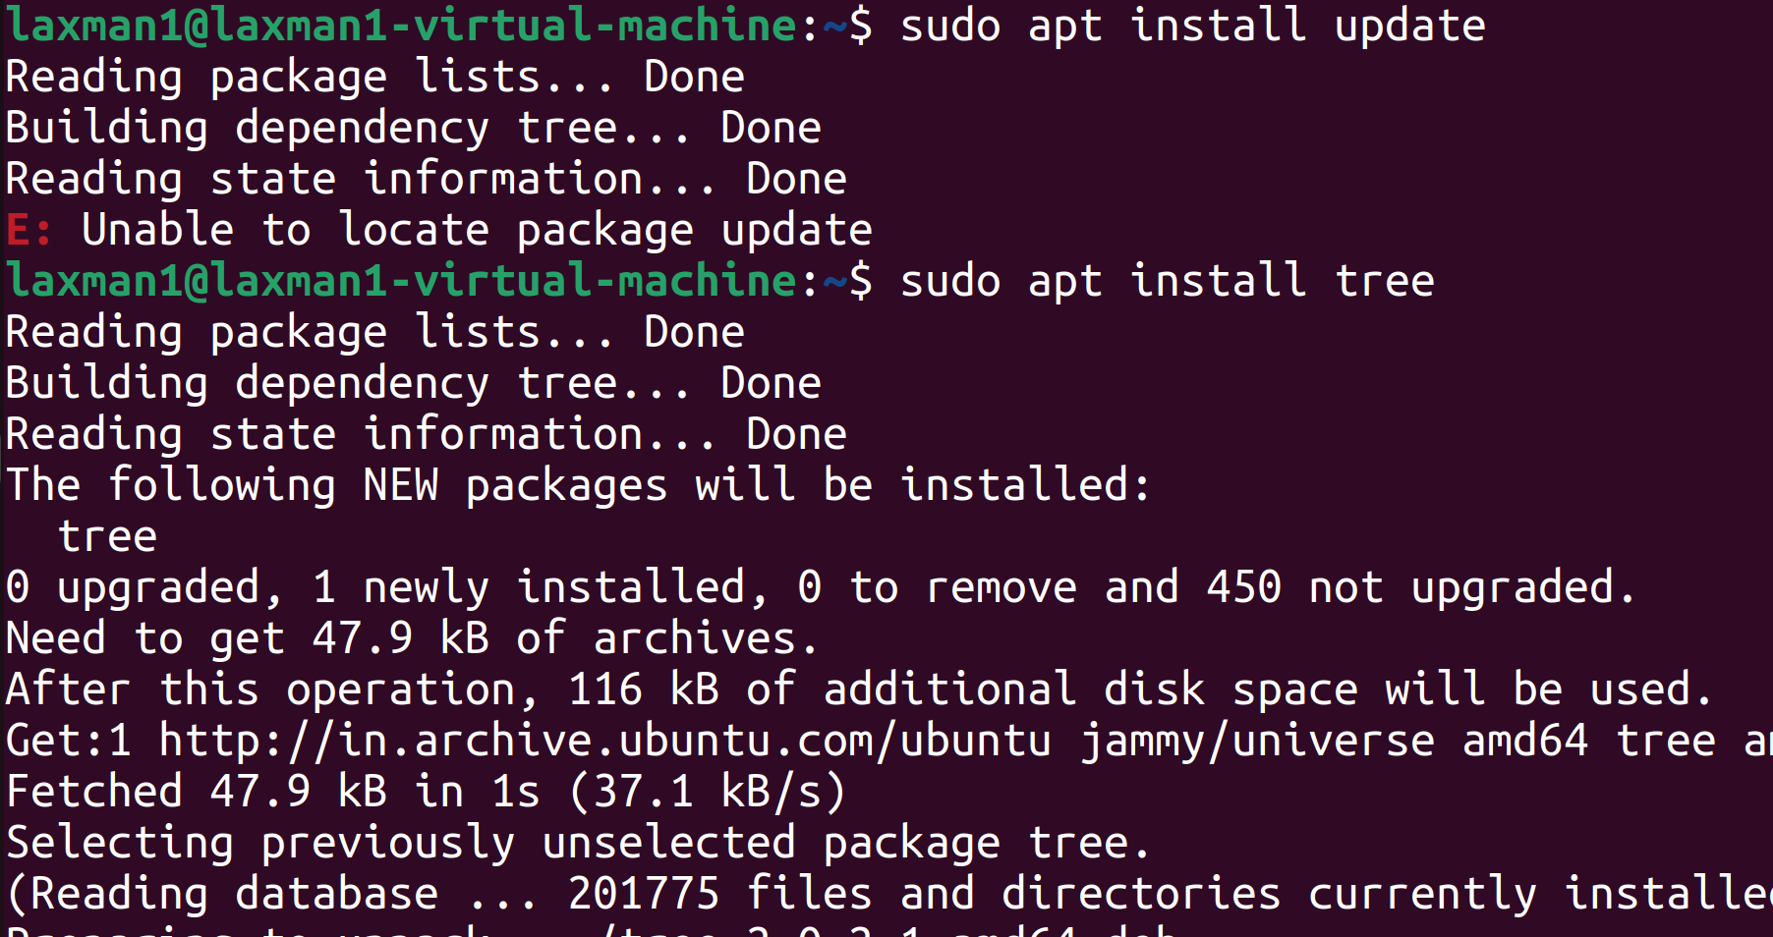

- Objective: Update installed packages.
Purpose: To keep the system secure and up to date.

Implementation:
Ubuntu/Debian: $sudo apt update
$sudo apt upgrade -y RHEL/CentOS: $sudo yum update -y

Conclusion: The system packages were updated successfully. 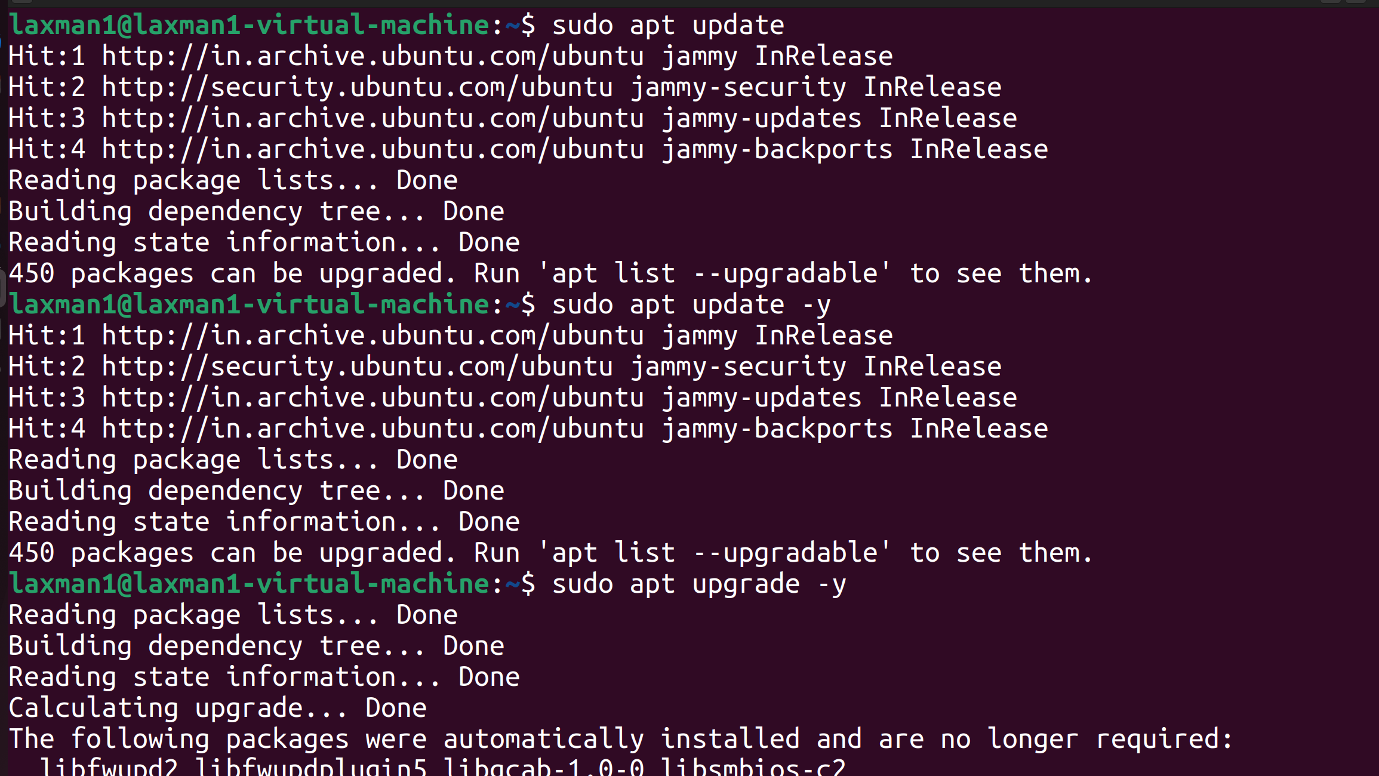

- Objective: Create a symbolic (soft) link. Purpose: To understand symbolic links. Implementation: $ln -s newfile.txt newfile_link Verify: $ls -ltr new*
Output: newfile_link -> newfile.txt
Conclusion: A symbolic link was created successfully.
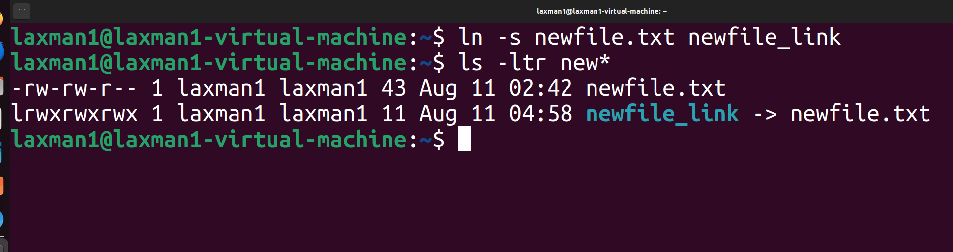
- Objective: Locate a file within the filesystem. Purpose: To learn file searching. Implementation:
Search in the current directory: $find . -name newfile.txt

Search for all .txt in all directory: $find . -name "newfile*" Search for all .txt files: $find . -name "*.txt"
Conclusion: The required file(s) were located successfully using the find command.

